**Adding report to Liferay portal guide**

**Steps:**

1. Go to this url <https://10.8.69.221/web/guest/report-setup> and login as “coadmin”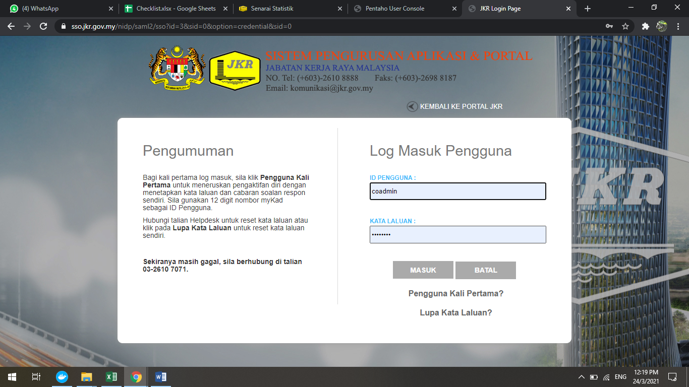
2. Navigate to “Dashboard and Reporting” and the page will show 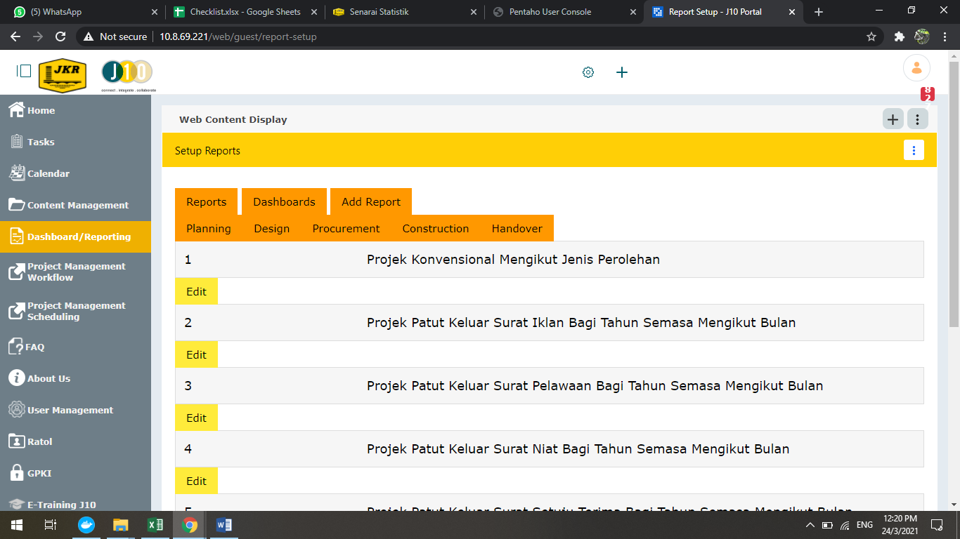
3. To edit data, click “Edit”. There are 4 spaces that needs to be entered data: Phase, Report ID, Report Name and URL. Once done, click update. (*note: fill all the blanks before clicking edit or add report).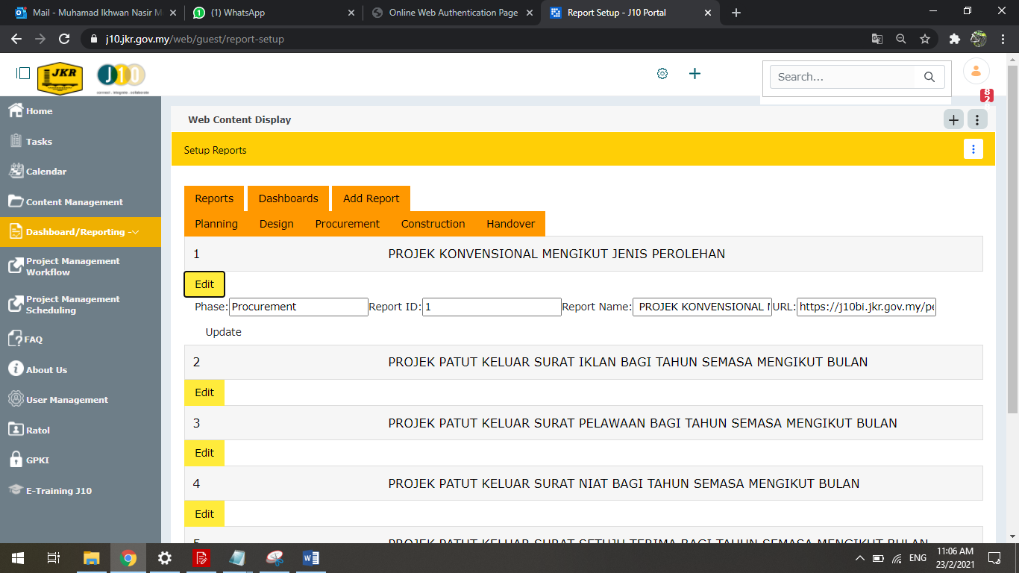
4. To add report, click the “Add Report”. Fill in the blanks and click “Add”.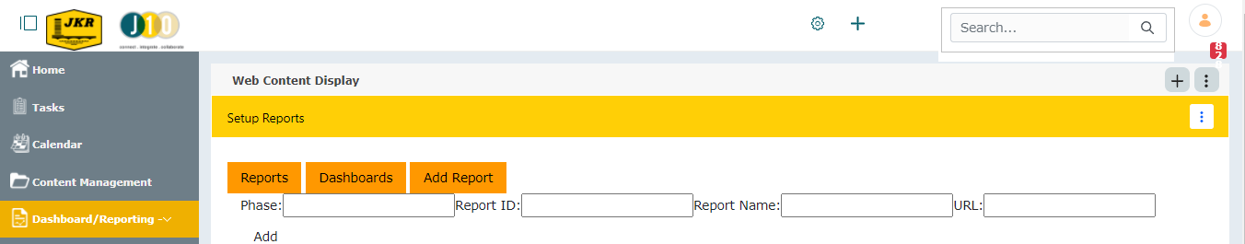
5. “Dashboard/Reporting” page.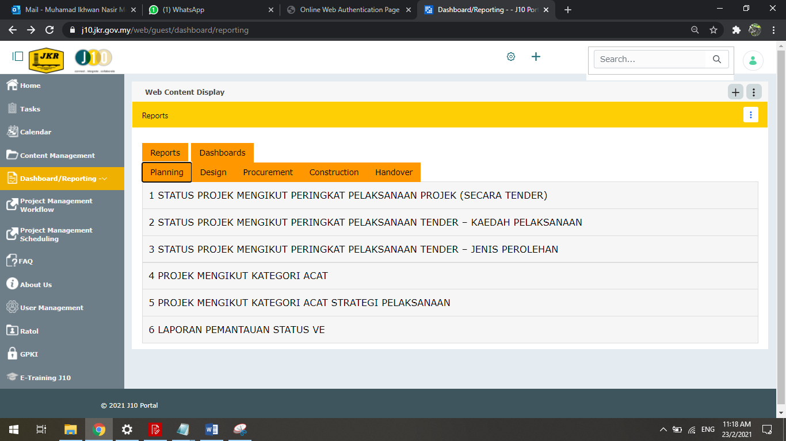

**How to add new report generated from pentaho?**

**Steps:**

1. Firstly, go to https://j10.jkr.gov.my/pentaho/Login and login SVSKC using 20c0dbd81f68d0bacb8b34ab5e0e5659 as password.

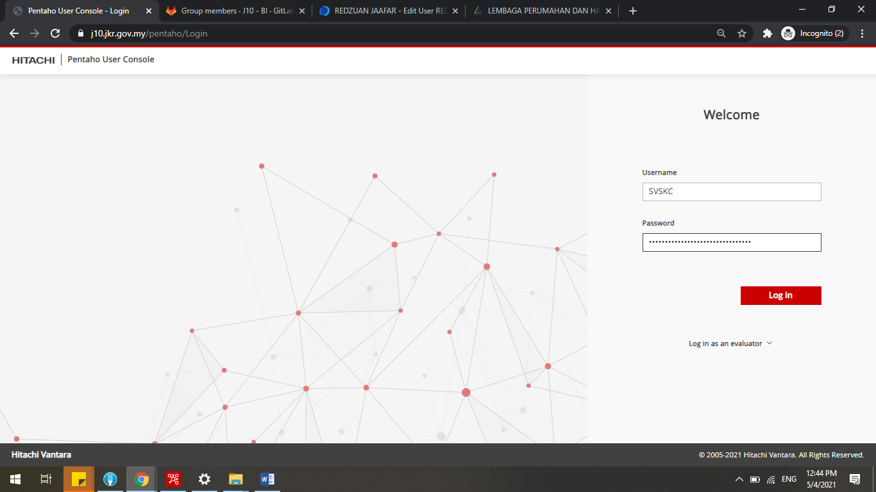

1. Once log in, the page will show as below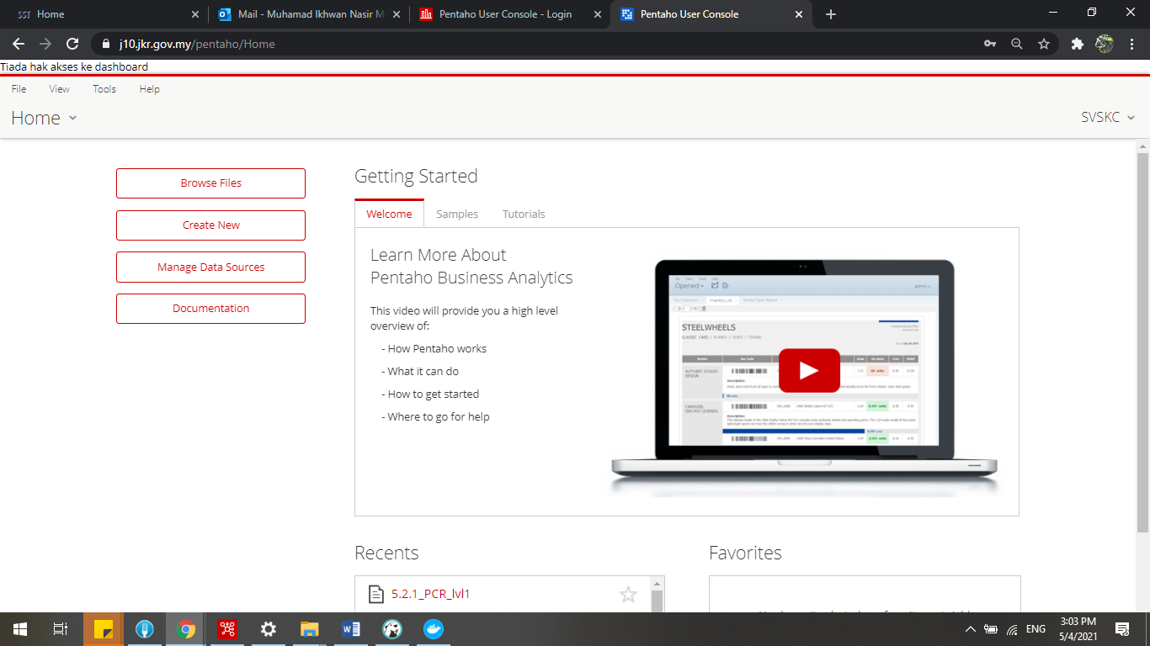
2. Go Browse Files > Public > J10_Report. This is where the reports been saved. 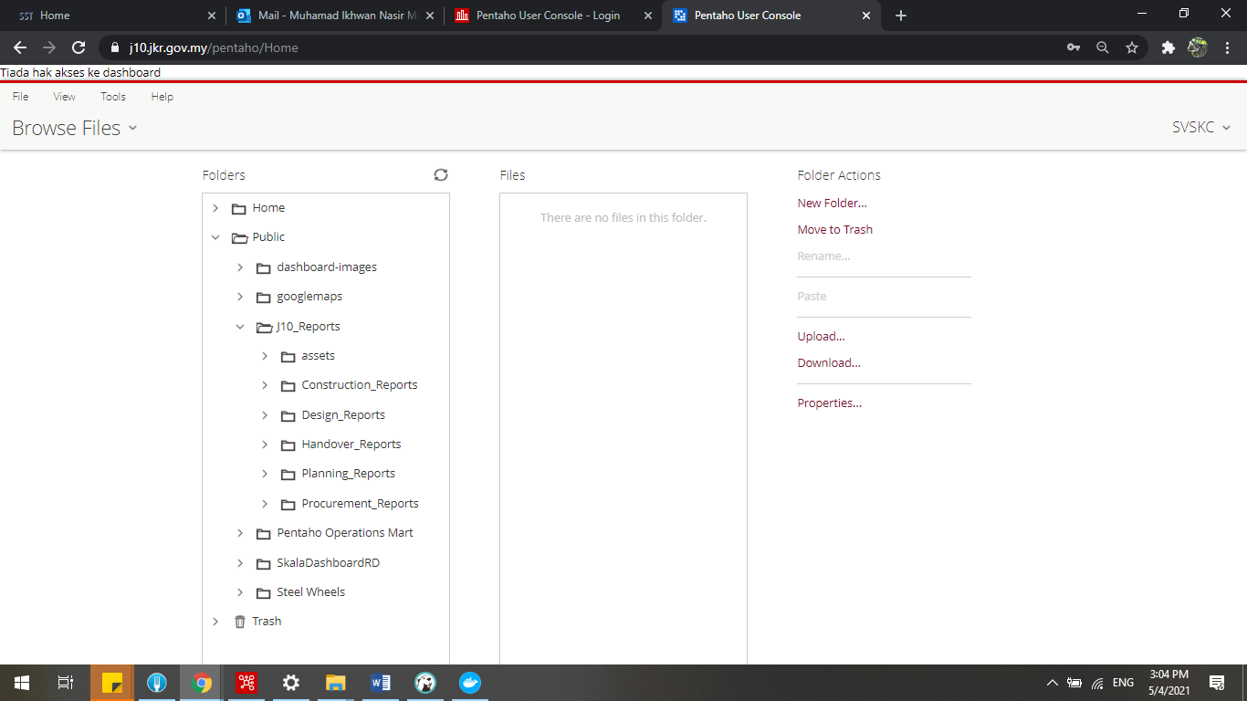
3. Each phase has their own report. To see report click “>” at the phase and choose the report. Then pick “lvl1” report and click “Open in a new window”. 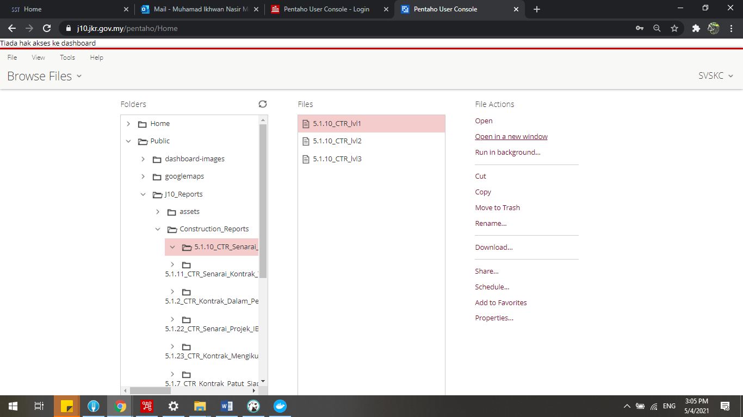

11

1. A window will popup. Use this URL to put in Liferay report page (refer step 4). 